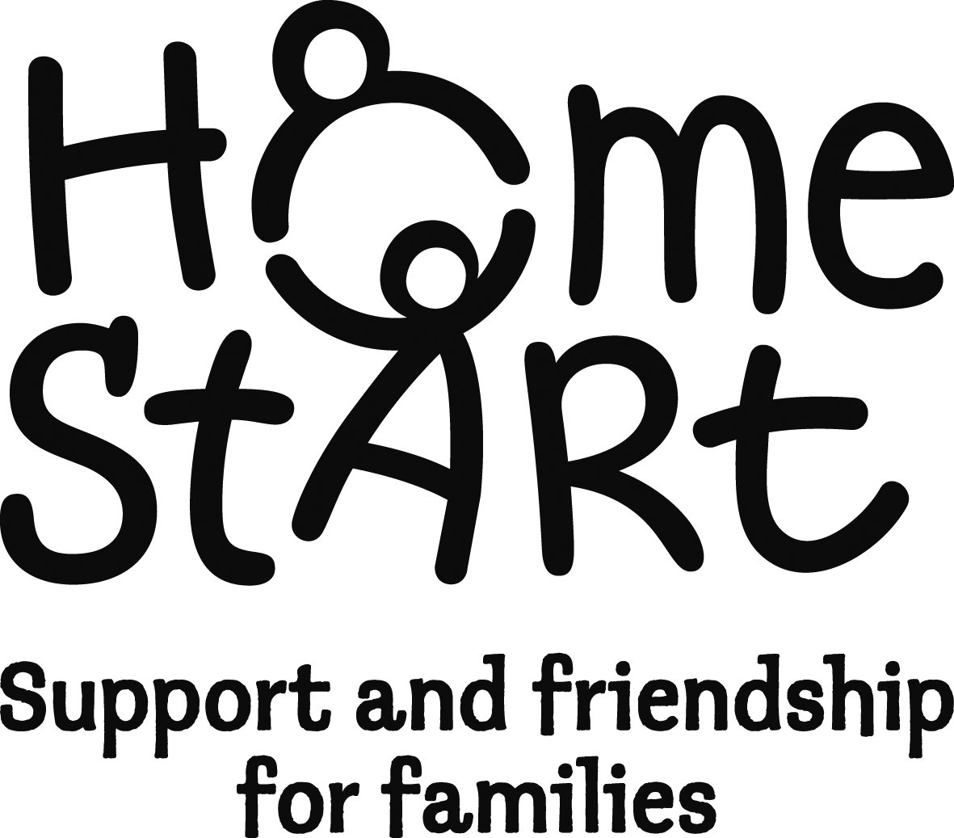
Referral Form Date referral received (scheme use) ___________

- Please note that all referrals must be made with the consent of the family. Have you discussed this referral with the family prior to completing this form?
YES / NO
- The family must have at least one child under the age of five years

Name of family……………………………………… Family Number (scheme use)……………………..
Address……………………………………………………………………………………………………………
………………………………………………………………Postcode …………………………………………
 | Name | Main carer | Resident in household | Disabled | Ethnicity
Mother/partner
Father/partner
Other main carer[s]
Tel. No ……………… Mobile No …………………..………E mail ……………………………………….

Referred by: Date of referral:

Name:  Agency:  Address:  Tel:  E mail | Family GP:  Health Visitor:  Other agencies involved:

Please √ all that apply to this family:

Lone parent | substance abuse | domestic abuse | mental health issues | learning disabilities | post natal depression | 19yrs or younger | other please specify

Details of children - (please include details of all children in the family)
Please add details of any additional children on the reverse of form
Child’s name- | DOB | Gender | Ethnicity | Are they disabled? | CAF | CinN  Plan | C P Plan

Family needs - So that we can offer the family the most appropriate support, and match the most suitable volunteer, please complete the following table.

Family needs | √ | If you have ticked, please tell us why this is a need and how Home-Start could support with this
1. Managing child’s behaviour
2. Being involved in the child(ren)’s development
3. Coping with own physical health

4. Coping with own mental or emotional health
5. Coping with feeling isolated

6. Parent’s self-esteem/ confidence

7. Coping with child’s physical health
8. Coping with child’s mental/emotional health

9. Managing the household budget
10. The day-to-day running of the house
11. Stress caused by conflict in the family
12. Coping with multiple birth/multiple children under 5
13. Use of other services

14, Other (please describe)
15. Is any member of the family involved in the Criminal Justice System?

Please add any background issues that we will need to consider when placing a volunteer:

HOME-START I.O.W RISK ASSESSMENT FORM
Please complete, as the referral cannot be processed without this form.

It is important that you give details of any possible risks or threats, including any relevant details relating to behaviour, health or the home environment.

Have you visited the family home? YES NO

If yes, what date did you last visit?

1/ What risk/ threat does the service user pose to staff/ volunteers?

2/ What risk/ threat does any other member of the service users family pose to staff/ volunteers?

3/ Is there any risk to staff/ volunteers from animals within the household?

4/ Are there any risks/ threats within the home environment?

Any other relevant information:

Referrers Signature ………………………………………… Date…………………………….

Please return this form to:

Home-Start I.O.W
Exchange House
St Cross Lane
Newport,
I.O.W PO30 5BZ
Tel: 01983 533357
E mail: admin@homestartiow.org
Referral form can be sent via e mail

We will try to respond to you within two weeks to tell you about progress with this referral.

We will remain in touch while supporting this family and will contact you when the support ends
If you have any issues or concerns about the referral process or the support for the family please contact
Alison Griffiths, Senior Co-ordinator

